Seán Hayes Paper 1 Master Document

# Title

A ##### Approach for Compressed Air System Operational Improvement Identification

# Abbreviated Title

Compressed Air Operational Improvement Identification

# Authors

Seán Martin Hayes*a, D.T.J. O’Sullivana

a Intelligent Efficiency Research Group (IERG), School of Engineering, University College Cork, Ireland

*Corresponding Author:

Name: Seán Martin Hayes

Postal address: Room 2.03,

Intelligent Efficiency Research Group (IERG),

School of Engineering,

Civil Engineering Building,

University College Cork,

College Road,

Cork,

Ireland.

Telephone: + 353 21 490 2913

Email: [sean.m.hayes@umail.ucc.ie](mailto:sean.m.hayes@umail.ucc.ie)

# Abbreviations

# Abstract

# Keywords

* Compressed Air
* Operational Improvement Identification
* Fault Detection and Diagnosis (FDD)
* System energy efficiency
* BMS data acquisition
* On-going commissioning

# Introduction

# Background

## Compressed Air

### Global Industrial and Air Compressor Energy Consumption

Statistics about global industrial energy consumption, and the proportion of energy usage that is used by air compressors. Copy format of previous chiller paragraph on this topic:

Compressed air is an essential utility in the modern industrial environment. Often referred to as the “fourth fuel”, it accounts for #####% of global industrial energy usage. Generated by various types and configurations of air compressors, compressed air is noted for being an inherently inefficient means of delivering energy. This is largely due to the significant amount of energy which

Space cooling in the buildings sector represents an important proportion of total primary energy use. In the United States, the buildings sector accounted for 41.1% of total primary energy consumption in 2010, with this figure set to remain relatively constant over the next 20 years [1]. Of this primary energy consumption, 14.8% is attributable to space cooling. This proportion is mirrored at the commercial level. Commercial buildings accounted for 18.6% of total primary energy consumption in 2010, of which space cooling represented 14.5%.

### Compressed Air as a Utility

Outline different types of compressors used in industry, basic description of principle of operation of each.

**Tree diagram for different compressor types.**

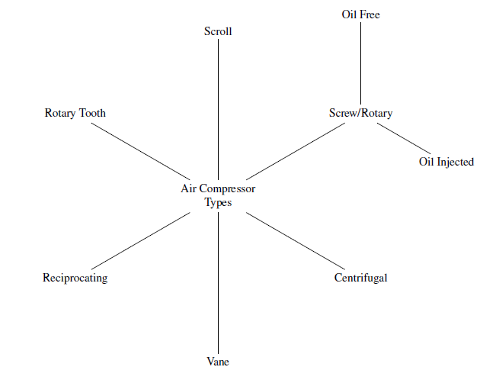

Outline common faults normally observed in air compressors. – **paste in from master list**.

## Case Study Details

### Pharmacy Building

Uses of compressed air.

* Compressed air at workbenches
* Specific machines – 24/7 usage

Typical usage profile **(chart)**. Zero usage (**Leakage rate – attempt to calculate from first principles with Pat Murphy’s help).**

### Compressors

Description of installed equipment:

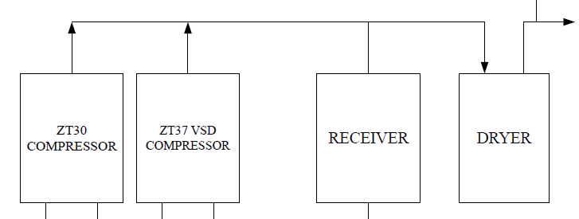

Description of current operational strategy:

TBC with Pat Murphy – Fixed speed machine is lead with VSD machine providing top up as necessary.

### Known Operational Issues

Description of cycling issue (**chart**).

Refer to leakage rate chart.

## Analytical Methods

Description of each of the following analytical methods:

* Neural Networks
* Mixture Model Classification
* Fuzzy Logic
* Regression Methods
* Instance-based methods
* Regularisation Methods
* Decision Tree Learning
* Bayesian Methods
* Kernel Methods (SVM)
* Clustering Methods
* Association Rule Learning
* Deep Learning Methods
* Dimensionality Reduction
* Ensemble Methods

One paragraph on each, followed by matrix of strengths and weaknesses.

Pick one method and provide justification for choosing it.

# Application of Method to Case Study

## Data Extraction

Description of how data was extracted from compressors.

## Outcome of Method

Description of issues and irregularities found using analysis method.

## Implementation of Outcome

If issues are found (e.g. cycling) then describe how they were remedied.

# Results

Define issues found and their effect numerically on operation.

Present savings if any achieved by remedying issues found.

# Analysis and Discussion

Discuss effectiveness of method in detecting operational issues on compressors.

Analyse savings figures – payback and commercial viability.

Sensitivity analysis of how different parameters affect results of defined method.

Error analysis – discuss sources of potential errors and how these may be minimised.

# Conclusion

# Scope

The paper is to assess the operation of the compressors in the UCC Pharmacy building.

This is to be done by reviewing the existing equipment’s operation, and applying an analysis method to data extracted from the PLC’s of the compressor.

The paper will initially present the context of compressed air as an industrial utility and its contribution to global energy consumption.

A review of typical compressor types, and common faults in operation observed on air compressors will be presented.

The analysis method will be chosen from a review of existing machine learning and statistical methods. The benefits and drawbacks of each will be discussed, and one method decided on.

The existing set up of compressed air in the UCC Pharmacy building will be presented, along with known issues in operation.

Following a description of how data was extracted from the compressors, the application of the chosen method to the compressor data will be presented. The outcome of this method will be the presentation of issues found with the compressor’s operation. The recommendations for remedying issues found will be discussed, and if possible their implementation discussed.

The results section will quantify the effect the issues identified are having on operation. Any savings achieved will be presented.

The analysis and discussion section will discuss the effectiveness of the chosen method in detecting operational issues. The savings figures will be analysed in terms of commercial viability. A sensitivity analysis and error analysis will also be presented.

# Journal Info

## Potential Journals

Using journal finder tools online, the following nine journals were identified as possible submission avenues for this paper.

1. Applied Energy
2. Applied Thermal Engineering
3. Automation in Construction
4. Building and Environment
5. Energy and Buildings
6. Energy and Buildings
7. International Journal of Refrigeration
8. Renewable & Sustainable Energy Reviews
9. Sustainable Cities and Society
10. Sustainable Computing

The highest ranking of these journals according to three key metrics are as follows:

1. Shortest editorial time: Building and Environment (3 weeks)
2. Highest impact factor: Renewable & Sustainable Energy Reviews (5.51)
3. Highest acceptance rate: Sustainable Computing (72%)

The three key metrics above are presented graphically in **Figure 1.**

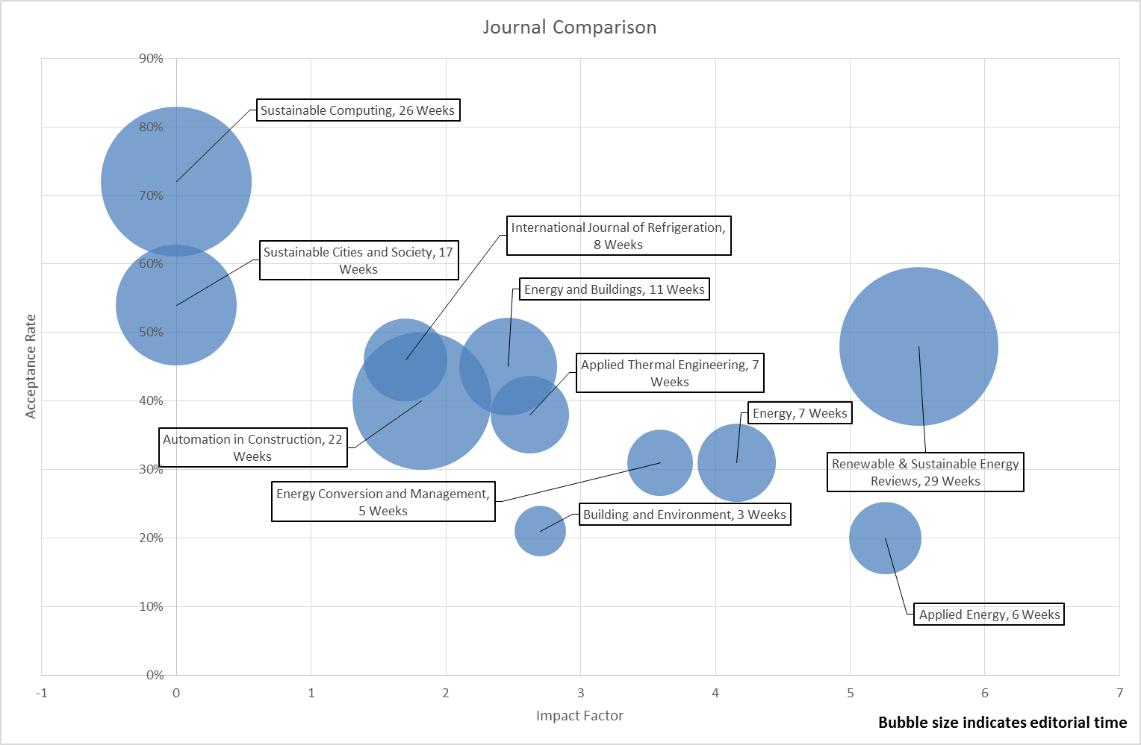

Figure 1: Journal Comparison

By scoring the journals in **Figure 1** on a high, medium or low basis of relative preference according to each of the three key metrics, and giving a general score for relevance to paper material (based on journal aims and objectives) the order of preference for submission is given in

|  |  |  |  |  |  |  |
| --- | --- | --- | --- | --- | --- | --- |
| ***Overall Rank*** | ***Journal*** | ***Impact Factor*** | ***Acceptance Rate*** | ***Editorial Time*** | ***Relevance (from scope)*** | ***Comment*** |
| 1 | Energy Conversion and Management | Medium | Medium | High | High | Most Relevant |
| 2 | Energy | High | Medium | Medium | Medium-High |  |
| 3 | Applied Energy | High | Low | Medium | High |  |
| 4 | Building and Environment | Medium | Low | High | Medium |  |
| 5 | Energy and Buildings | Medium | Medium | Low | Medium |  |
| 6 | Applied Thermal Engineering | Medium | Medium | Medium | Low | Topic not quite relevant |
| 7 | International Journal of Refrigeration | Low | Medium | Medium | Low | Topic not quite relevant |
| 8 | Renewable & Sustainable Energy Reviews | High | Medium | Low | Low | Editorial time too long |
| 9 | Sustainable Cities and Society | Low | High | Low | Low | Editorial time too long |
| 10 | Sustainable Computing | Low | High | Low | Low | Editorial time too long |
| 11 | Automation in Construction | Medium | Medium | Low | Medium | Editorial time too long |

Table 1**.**

|  |  |  |  |  |  |  |
| --- | --- | --- | --- | --- | --- | --- |
| ***Overall Rank*** | ***Journal*** | ***Impact Factor*** | ***Acceptance Rate*** | ***Editorial Time*** | ***Relevance (from scope)*** | ***Comment*** |
| 1 | Energy Conversion and Management | Medium | Medium | High | High | Most Relevant |
| 2 | Energy | High | Medium | Medium | Medium-High |  |
| 3 | Applied Energy | High | Low | Medium | High |  |
| 4 | Building and Environment | Medium | Low | High | Medium |  |
| 5 | Energy and Buildings | Medium | Medium | Low | Medium |  |
| 6 | Applied Thermal Engineering | Medium | Medium | Medium | Low | Topic not quite relevant |
| 7 | International Journal of Refrigeration | Low | Medium | Medium | Low | Topic not quite relevant |
| 8 | Renewable & Sustainable Energy Reviews | High | Medium | Low | Low | Editorial time too long |
| 9 | Sustainable Cities and Society | Low | High | Low | Low | Editorial time too long |
| 10 | Sustainable Computing | Low | High | Low | Low | Editorial time too long |
| 11 | Automation in Construction | Medium | Medium | Low | Medium | Editorial time too long |

Table 1: Journal Rankings

### Energy Conversion and Management

The journal *Energy Conversion and Management* provides a forum for publishing original contributions and comprehensive technical review articles of interdisciplinary and original research on all important energy topics.

The topics considered include energy generation, utilization, conversion, storage, transmission, conservation, management and sustainability. These topics typically involve various types of energy such as mechanical, thermal, nuclear, chemical, electromagnetic, magnetic and electric. These energy types cover all known energy resources, including renewable resources (e.g., solar, bio, hydro, wind, geothermal and ocean energy), fossil fuels and nuclear resources.

Papers are welcome that investigate or consider the prospects of energy technologies, devices, systems, materials, processes, operation, performance, maintenance and control.

Priority may be given to interdisciplinary energy subjects that deal with advanced technologies and that consider more than one of these methodologies: modeling, experimental, analysis and optimization, with appropriate verifications of the findings.

### Energy

Energy is an international, multi-disciplinary journal in **energy engineering** and research. The journal aims to be a leading peer-reviewed platform and an authoritative source of information for analyses, reviews and evaluations related to **energy**. The journal covers research in mechanical engineering and thermal sciences, with a strong focus on energy **analysis**, energy **modelling** and **prediction**, **integrated energy systems**, energy **planning** and energy **management**. The journal also welcomes papers on related topics such as energy conservation, energy efficiency, biomass and bioenergy, renewable energy, electricity supply and demand, energy storage, energy in buildings, and on economic and policy issues, provided such topics are within the context of the broader multi-disciplinary scope of Energy.

Keywords:

### Applied Energy

*Applied Energy* provides a forum for information on innovation, research, development and demonstration in the areas of **energy conversion** and**conservation**, the optimal use of **energy resources**, analysis and optimization of **energy processes**, mitigation of **environmental pollutants**, and **sustainable energy systems**. The journal publishes original papers, review articles, technical notes, and letters to the [editor](http://www.journals.elsevier.com/applied-energy/editorial-board/). Authors are encouraged to [submit](http://ees.elsevier.com/apen) manuscripts which bridge the gaps between research, development and implementation. The breadth of coverage ranges from innovative technologies and systems of both fossil and renewable energy to the economic industrial and domestic use of energy with no or minor impact on the environment. *Applied Energy* is also concerned with the attendant problems of modeling and forecasting, conservation strategies, and the environmental, social and economic impacts of energy policies and usage, including climate change mitigation and other environmental pollution reduction.

### Building and Environment

Building and Environment is an international journal that publishes original research papers and review articles related to building science and human interaction with the built environment.

The Journal invites research articles conveying robust, tested knowledge on:

•technologies and integrated systems for high performance buildings and cities

•thermal, acoustic, visual, air quality building science and human impacts

•tools for the design and decision-making community, including tested computational, economic, educational and policy tools.

•solutions for mitigating environmental impacts and achieving low carbon, sustainable built environments.

The Journal is focused on new knowledge, rigorously verified with measurement and analysis, related to the environmental performance of buildings in different scales, ranging from cities, communities, buildings, to building systems and assemblies.

### Energy and Buildings

An international journal devoted to investigations of energy use and efficiency in buildings

Energy and Buildings is an international journal publishing articles with explicit links to energy use in buildings. The aim is to present new research results, and new proven practice aimed at reducing the energy needs of a building and improving indoor environment quality.

* Topics covered include:
* Energy demands and consumption in existing and future buildings - prediction and validation
* Indoor environment quality, including health and thermal comfort vis-à-vis energy
* Natural, mechanical and mixed ventilation
* Air distribution in buildings
* Application of solar and other renewable energy sources in buildings
* Energy balances in building complexes (residential, commercial, industrial, public and other buildings)
* Energy efficiency improvement measures of HVAC&R and other technical systems in residential, commercial, public and industrial buildings, and semi open built spaces
* Heat recovery systems in buildings
* Buildings and district heating and cooling
* Energy conservation in built environment
* Energy efficient buildings
* Building physics
* Energy sustainability, resilience and climate adaptability of buildings
* Evaluation and control of indoor thermal and lighting systems
* Building's total performance and intelligent buildings
* Links between architectural design, mechanical and lighting systems
* New materials in buildings and their impact on energy demands
* External and internal design conditions for energy efficient buildings
* Building envelope materials and structure energy performance
* Thermal energy storage and thermally active building systems - TABS
* Energy performance of buildings and modeling predictive control
* Zero CO2 emission - zero energy and energy plus buildings and their smart grid harmonized operation
* Residential/municipal energy refurbishment and renovation
* Life cycle energy efficiency of buildings and embodied energy
* Architectural structure - construction energy efficiency
* Energy related aspects of buildings after catastrophic events

Papers with results based on simulations are welcome but those with clear links to laboratory or field measurements are preferred. These links may include calibration, benchmarking, or comparisons of results.

### Applied Thermal Engineering

*Applied Thermal Engineering* publishes original, high-quality research papers and ancillary features, spanning activities ranging from fundamental research to trouble-shooting in existing plant and equipment.

**Component** and **system design**covers energy use both in the process and power industries, and in buildings, including passive thermal design techniques. For the former, the design problems associated with the integration of components into overall plant are also covered. Additionally, the reduction of water use and pollution prevention are of interest.

The journal features aspects of the **thermal engineering** of **advanced processes**, including process integration, intensification and development, together with the application of thermal equipment in process plants. The optimisation of processes to maximise performance is also included.

A wide range of **equipment** is relevant to *Applied Thermal Engineering*, such as heat exchangers (compact and advanced designs), heat pumps and refrigeration plant, heat pipes, combined heat and power and advanced cycles, polygeneration, heat transfer enhancement as applied to the above, and other unit operations involving thermal engineering procedures, including those related to renewable sources.

The **application** of thermal engineering is becoming critical in specific areas such as aerospace, electronics thermal management and medicine, as well as equipment used by the armed forces. Papers on such challenging applications are often a springboard for technology transfer to other areas, and are encouraged. Short communications in the form of 'Case Studies' will be considered.

A theme running through many papers will be **energy**. Energy conservation, including heat recovery, the rational use of energy and**renewable energy technologies** are inevitable features of thermal engineering across all applications. As we see an increasing interest in the use of, for example, renewable energy including solar energy in the process industries, the integration of renewable energy and 'conventional' processes is a topic of relevance. Improved efficiency and alternative equipment for reducing emissions is an increasingly important aspect of all energy use.

**Economics** plays a necessary role in the assessment of many thermal engineering projects. Submissions devoted to or considering the**financial implications** of equipment designs are welcome. Information on the different economic criteria applying in particular regions of the world is relevant.

Review articles on appropriate topics are encouraged. Before submitting such a paper, please contact one of the Regional Editors, or the Editor-in-Chief, with an outline of your proposed paper and your expertise in the area of your review.

Additional features include:  
• Special issues devoted to emerging topics and new developments in the field  
• Book reviews  
• Policy and legislation reports related to the topics of *Applied Thermal Engineering*.

The [Editors](http://www.journals.elsevier.com/applied-thermal-engineering/editorial-board/) welcome letters on topics that readers feel are of interest to a wider audience.

*Applied Thermal Engineering* provides essential reference material and critical design feedback, with emphasis on thermal technologies as applied across a wide range of fields.

All [submissions](http://ees.elsevier.com/ate/) will be subject to peer review from leading experts in the field.

# Old – Draw on as necessary

## Scope

The paper is to comprise a review of methods used for improving industrial utility equipment operation, followed by a demonstration of a particular method to improve a particular system.

 The paper will condense the ICEBO paper to an initial review section, followed by an outline of the problem to be solved, a description of the method used to solve the problem, and presentation of results.

 The data source for the paper's problem solving method is to be the heating network and/or the air compressors in the UCC Pharmacy building.

 If the control panels on the air compressors in the Pharmacy building can be accessed (currently Atlas Copco are arranging quotes to provide this) then it would allow for quite detailed equipment level data to be analysed for the compressors and dryer. The intention of the analysis would be to determine if the compressor is running in an energy efficient state. It is intended that the method used for chiller analysis at UC Berkeley be drawn on for this. A known issue with the air compressors is that they are rapidly cycling on and off, this will be incorporated into the analysis.

## Necessary Parameter Identification

Define what the necessary parameters for compressor monitoring are. Draw this from list compiled previously from library e-book. Explain likely issues that can be highlighted by analysing each parameter.

## Data Acquisition and Storage

Discuss how the data is extracted from the compressor PLC, and exported to a host machine.

## Selection of Appropriate Distribution

Analyse distributions of all parameters and compare fit of standard distributions, and pick the best fitting one.

## Formulation of Mixture Model

Definition of bands of operation.

Measure most likely will be:

* Compressed air delivery vs. energy consumption.
* Cycling frequency of compressor
* Cycling frequency of dryer

Talk about means of generating mixture model (Expectation Maximisation or Gibbs Sampling). Likely will be EM due to Matlab’s capabilities in this.

## Defined Improvement Opportunities

Come up with 4-5 defined opportunities for improvement that were identified using classification of operation into various bands.